Biological limits to lifespan do not explain the recent slowdown in UK life expectancy

Devine RE, McCartney G, Minton J

WORDS 2422 (excluding figures, legends and references)

Abstract

Background

In the UK there has been a notable slowdown in rates of improvement in life expectancy in recent years. One intuitive interpretation of these facts is that there is a maximum biological limit to lifespan, and that as we approach this limit, rates of improvement will slow. This paper introduces and updates some key demographic findings to investigate whether the recent slowdown is explained by such a phenomena.

Methods

Analyses presented in two demographic papers, White (2002) and Christensen (2009), were replicated, adapted, and updated with new data available from the Human Mortality Database (HMD). For the 21 countries chosen by White, we have graphed life expectancy over time; calculated r2 to examine the linearity of those trends; graphed life expectancy against annual change in life expectancy to examine whether life expectancy improvements are advancing or moving towards zero improvement; and we have graphed the change in life expectancy for 21 countries over 6 decades to examine the evolution of the gradient of life expectancy improvement.

Results

Life expectancy at birth for the 21 countries analysed showed a linear improvement from 1955 to 2016. Our update of the analysis by White et al suggests substantial improvements in life expectancy (around 0.15 – 0.20 years/year) across a number of countries, rather than the zero improvements that would be expected if a biological limit to lifespan was being reached.Additionally, the UK has shifted from being among the countries with the highest life expectancies to having a slightly below average life expectancy.

Conclusion

The recent slowdown in life expectancy gains observed in the UK cannot be explained by a general tendency for life expectancy improvement rates to slow down as life expectancy increases. Other explanations are required as to why improvements have slowed since 2012, including those considering the influence of fiscal policies and economic change.

Introduction

It could be argued that the substantial reduction in human mortality, and the resulting increase in life expectancy, has been the greatest achievement of the last 150 years.[1] Period life expectancy at birth has generally increased since the 1950s across high income countries.[2, 3] Improvements in life expectancy have variously been attributed to improvements in nutrition, sanitation, housing, education, institutions, the welfare state, disposable incomes as well as healthcare, in particular vaccines and antibiotics.[4–7] Since the end of the second world war, improvements in survival have continued, largely propelled by decreases in mortality during adulthood. Until very recently, only severe epidemiological or socio-political shocks, such as the 1918 influenza pandemic, the world wars and the rapidly changing politics and economics in the Soviet Union, have interrupted the steady rise in life expectancy across high income countries.[8] Economic recessions alone have generally not had an impact on overall life expectancy because of the mixed impacts across different causes of death.[9]

However, life expectancy in the UK, and across many high income countries, has been stalling since 2012 and, in some countries, has started to decline.[10–13] Given that many high income countries have seen improving life expectancy for many decades, it has been suggested that the easiest gains in population improvements have already been made and that such a slowdown in life expectancy is to be expected as a result of approaching a biological limit to lifespan. [14]

If there is a biological maximum limit to lifespan, it can be anticipated that, as populations age, more of the population will reach this upper lifespan limit and so trends towards ever increasing life expectancies would tail off. Additionally, there would be a notable slowdown in the rate of annual improvement in life expectancy, seen first in those countries with the highest life expectancies. Some commentators believe that, since the UK already has a high life expectancy, further improvements at the high rates previously experienced cannot be expected. If this is correct, it would be expected that: (i) globally, the countries with the highest life expectancies would see the most reduced improvement in life expectancy; (ii the rate of life expectancy improvement would advance less quickly over time; (iii) in the UK, those (least deprived) sectors of the population with the highest life expectancy would see the most reduced improvement; and (iv) stalled overall improvements would be due to static mortality rates for older age strata rather than because of increasing mortality rates at younger ages.

This paper explores whether any long-term tendency for rates of life expectancy improvement to slow down could explain the recent trends in the UK.

Methods

We followed the methods used to produce figure 1 and figure 3 of White 2002.[15] White’s paper showed period life expectancy for the unweighted average of 21 high income countries (Australia, Austria, Belgium, Canada, Denmark, Finland, France, West Germany, Greece, Ireland, Italy , Japan, Netherlands, New Zealand, Norway, Portugal, Spain, Sweden, Switzerland, United Kingdom, United States) and we have re-analysed and updated to include data from 1955 to 2016. We conducted supplementary analyses by repeating our analyses including all 40 countries included in the Human Mortality Database for which data were available.

We further extend White’s research and conclusions about life expectancy in a number of ways: first, we replicate and update White’s Figure 3 from the period 1955-1996 to 1955-2016, with data form the HMD. Second, for the 21 countries chosen by White, we have graphed life expectancy over time; calculated r2 to examine the linearity of those trends. Third, we produce a version of this same graph considering each decadal period from 1955-2016 separately, to investigate both the evolution of this relationship and whether it has become more or less supportive of biological limits as a key explanation; within each of these decadal periods we also highlight the UK, to show how its life expectancy compares against the other high income nations.

Data and Code

All analyses make use of data from the Human Mortality Database (HMD), using data, where available, for those 21 high income countries included in White’s paper. Analyses were performed using the R programming language [R Core Team (2017). R: A language and environment for statistical computing. R Foundation for Statistical Computing, Vienna, Austria. URL [https://www.R-project.org/](https://www.r-project.org/)], and all code required to replicate the analyses is publically available on a GitHub repository.[1] Data availability for all the countries in HMD is illustrated in the supplemental data.

Results

The trend of improvement in life expectancy for high income countries since 1996

White’s paper analysed data from 1955 to 1996. Life expectancy at birth for the 21 countries analysed showed a linear improvement from 1955 to 2016. Life expectancy seems to have been improving faster between 1955 and 2016 (0.216 years/year on average), than between 1955 and 1996 (0.211 years/year on average; data not shown). This indicates that the stalling across many countries has not been sufficient to drop the average increase (when data up to 2016 are included).

Life expectancy at birth in the UK fell below the average of these 21 high income countries in the 1960s, started to converge in the 2000s and then fell back after 2012 (Figure 1b).

Linear regression for life expectancy over time demonstrated a near perfect R-squared value (> 0.99) for data between 1955 and 2016 (see table 1). The ‘lowest’ and ‘highest’ categories refer to the country with the lowest and highest life expectancy at birth in 1955. R squared values of this magnitude indicate the high degree of linearity in the improvement in life expectancy in these countries over time. The t statistics are all very large, and correspond to p values much smaller than 0.01. These analyses were repeated with all countries listed in the Human Mortality Database (see supplemental data).

.

*Table 1: R squared values of life expectancy at birth in 1955 for 21 countries against average annual gain in life expectancy per year between 1955 and 2016.*

|  |  |  |  |  |  |  |
| --- | --- | --- | --- | --- | --- | --- |
| **Population** | **Life expectancy at birth in 1955** | **Average annual gain per year between 1955 and 2016** | **Standard Error** | **t value** | **R squared** | **Adj. R Squared** |
| Lowest | 61.400 | 0.299 | 0.007 | 41.250 | 0.966 | 0.965 |
| Highest | 73.430 | 0.198 | 0.004 | 52.871 | 0.979 | 0.979 |
| Average | 69.094 | 0.216 | 0.001 | 152.118 | 0.997 | 0.997 |

Table 2: country codes for Figure 2

|  |  |
| --- | --- |
| **CODE** | **COUNTRY** |
| AUS | Australia |
| AUT | Austria |
| BEL | Belgium |
| CAN | Canada |
| CHE | Switzerland |
| DEUTW | Germany (West) |
| DNK | Denmark |
| ESP | Spain |
| FIN | Finland |
| FRATNP | France Total Population |
| GBR_NP | United Kingdom Total Population |
| GRC | Greece |
| IRL | Ireland |
| ITA | Italy |
| JPN | Japan |
| NLD | Netherlands |
| NOR | Norway |
| NZL_NP | New Zealand Total Population |
| PRT | Portugal |
| SWE | Sweden |
| USA | United States of America |

Figure 1(a): Mean life expectancy of high income countries from 1955 – 2016; r2 = 0.99

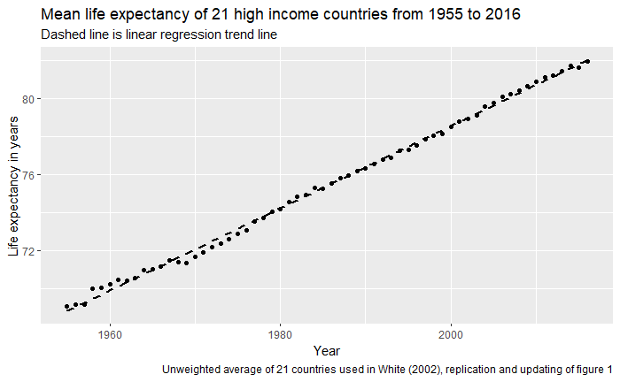

Figure 1(b): Life expectancy over time for average of high income countries and the UK, showing the UK’s relative position and stalling life expectancy after ~2012 (1955-2016).

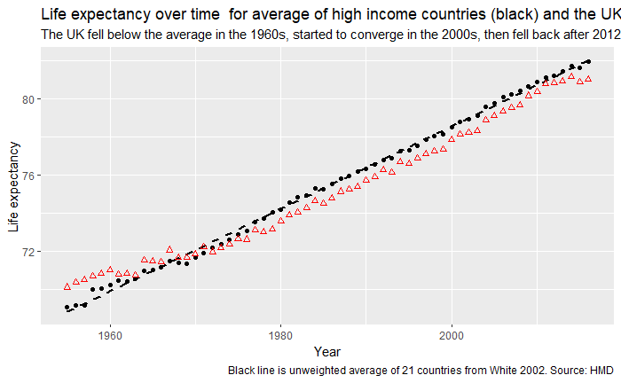

The rate of improvement in life expectancy

If a limit were being approached, life expectancy improvement would advance less quickly over time. When we look at average annual change in life expectancy, data are suggestive of a lower limit of around 0.15 – 0.20 years/year improvement; 1.5 to 2.0 years a decade. Over the studied period of time, the rate of advance in life expectancy has settled at this rate of improvement rather than slowed to zero improvement.

Figure 2 shows data for the life expectancy at birth in 1997 for 21 high income countries, against average annual change in life expectancy in years per year, between 1955 and 2016.

In 1997 USA had one of the lowest life expectancies at birth and Japan had the highest by a substantial margin. The improvement each year is across a narrower range for these countries.

By splitting the data in to decadal periods (Figure 3) we can see more clearly the evolution of the gradient over time. We note that, based on the gradient, all countries except USA could expect improvement of above 1.5 years per decade. This suggests that while the rate of LE improvement is slower with increasing life expectancy, there is still a substantial improvement, rather than evidence of improvements stopping as an absolute ceiling is reached for countries with the highest LE.

Considering the relationship between contemporary life expectancy and the rate of change in life expectancy in Figure 3, the inverse relationship has become both less certain and less of a gradient over time, the opposite of what would be expected if a ‘natural’ ceiling was to be reached. Furthermore, the rate of improvement over time across countries converges at around 0.15 to 0.20 years of life expectancy improvement per year from a much wider spread of rates in the earlier period. Again, we would expect convergence at zero as life expectancy increases if a biological limit was the cause.

For each of the decades the position of the highlighted point in the horizontal distribution shows the relative ranking of life expectancy for the UK compared with the other high income countries in this group. We can see that it has shifted from one of the higher life expectancy countries, to having a slightly below-average life expectancy over time. This again runs counter to the idea that a general tendency towards life expectancy slowdown explains the recent data, as then we would expect countries like Japan and Norway to have experienced the largest slowdowns in recent years. This was not illustrated when the larger group of HMD countries was analysed (see supplemental data).

*Figure 2: life expectancy at birth in 1997 for 21 high income countries, against average annual change in life expectancy in years per year, between 1955 and 2016. See table 2 for country codes.*

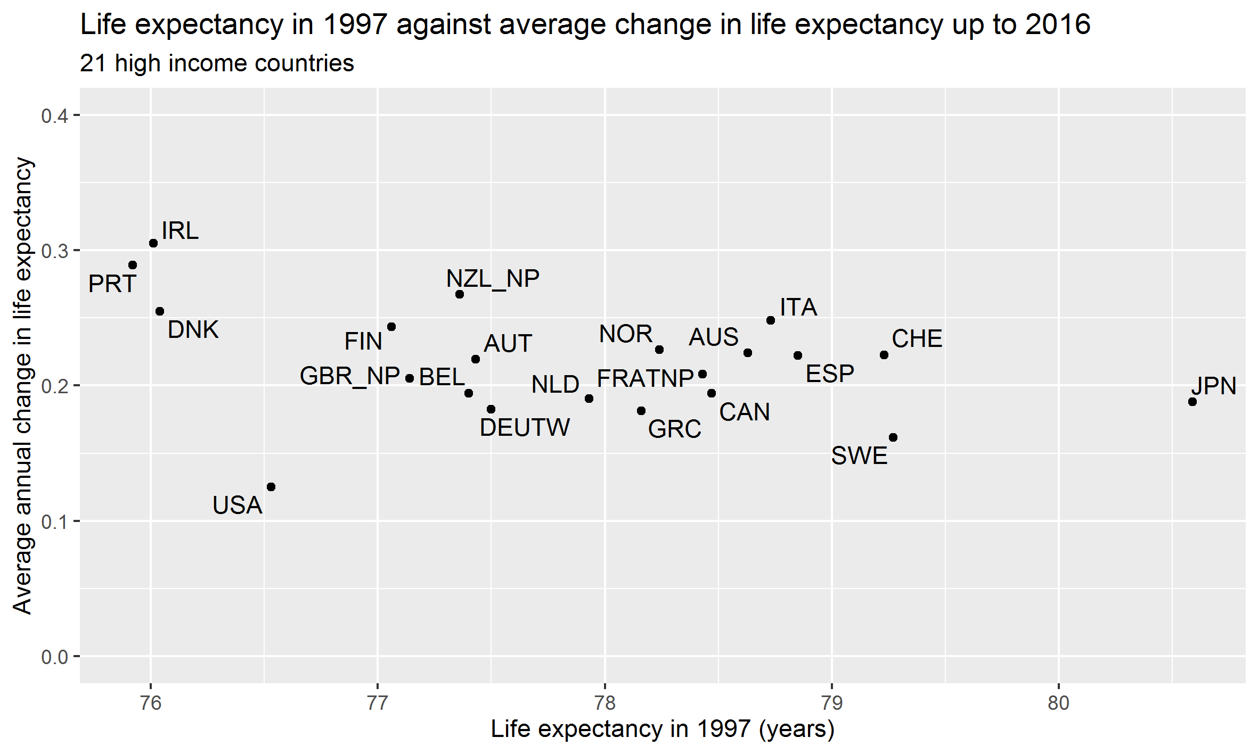

Figure 3: life expectancy at birth at start of decade for 21 high income countries, against average annual change in life expectancy (in years per year) over 6 decades

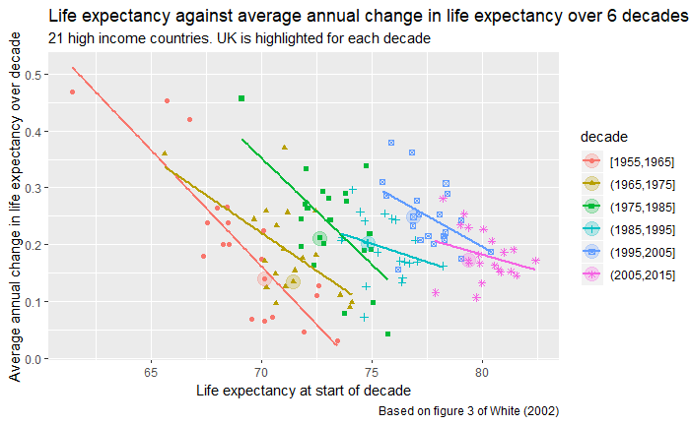

Discussion

Overall, these analyses have demonstrated that (i) the linear improvement in life expectancy in the group of high income countries studied by White et al has continued 20 years longer than shown in White’s analysis; (ii) there are continued rapid improvements in the highest LE countries (iii) while the long-term inverse relationship between life expectancy and rate of improvement in life expectancy has become weaker over time, it does seem to be settling at around 0.15- 0.20 years/ year improvement. If the slowdown in LE improvement in the UK is due to a biological limit we would expect the United Kingdom to be less affected by this biological limit since we are further down the Life expectancy ‘league table’ overall; in fact we are worse affected than countries like Japan which have better LE.

Strengths

We provide an intuitive graphical means of investigating whether the stalling of life expectancy across countries is likely to be due to populations reaching a natural limit to human lifespan.

In the paper by White et al, 21 high income countries were chosen because they were industrially developed, internally at peace, had a population in the millions throughout the period, and had complete data back to 1961. These were considered to be a comparable group with respect to life expectancy. We chose to perform updated analyses on the same group of countries as chosen by White et al, to allow comparison within order to see if these findings are replicated when more recent data is included.

**Limitations/further research**

The results using all HMD countries aren’t really similar, but in ways that are understandable and support White’s choice of the 21 countries as high income ‘first world’ countries in 2002. The main difference is a discontinuous rate of improvement for the average, with a faster rate of improvement between the mid 1990s and mid 2000s, and a much less linear and shallower improvement for the worst performing countries (see supplemental data).

There are issues with data availability when including all HMD countries, which results in like not being compared with like; when repeating our analysis of life expectancy since 1955, it is not possible to include all HMD countries since good quality data for some of these countries were not added to the database until the mid-1980s (see supplemental data).

In addition, using data from this broader range of countries may introduce a confounder of demographic transition; the group includes data on Russia and Eastern European Countries which may be at a different stage of economic development. Historically, formerly Soviet-controlled nations tended to exhibit faster rates of life expectancy improvement and started to converge more towards Western and Central European nations.

Further analysis could include weighted rather than unweighted average life expectancies. We have only looked at high income countries; this is not a comprehensive international analysis.

In comparison with other studies

In addition to these analyses, comparison with previous published work contributes to our investigation of whether a limits-to-lifespan hypothesis could explain the recent stalling in life expectancy in the UK.

There are other logical reasons as to why the recent trends in the UK cannot be due to natural biological limit. If a maximum human lifespan did exist, and is being reached in the UK, those (least deprived) sectors of the population with the highest life expectancy would see the greatest reductions in the rate of improvement, while the most deprived would continue to make faster gains. Fenton et al 2018 demonstrated clearly this was not the case in Scotland. Public Health England have shown that inequalities are rising in England also (REF). Fenton et al’s analysis of percentage change in age-standardised mortality rate by deprivation quintile in Scotland showed that age-standardised mortality rate worsened between 2012 and 2017 in the most deprived fifth of the population, compared with the least deprived.[16] Rather than reaching a biological maximum limit to lifespan, it is possible that life expectancy data in the UK is being driven by increasing inequality in mortality rates; by those most deprived population groups who are suffering the lowest life expectancy.

In addition, if a maximum limit to lifespan was being reached, stalling of life expectancy would be noted in the oldest age groups first. This is contrary to a recently published decomposition analysis of mortality trends in Scotland.[17] The authors found that a wide range of causes of death was responsible for the observed changes in life expectancy growth in Scotland since 2012, and reported almost all age-groups saw worsening mortality trends. Life expectancy trends are being impacted by increases in mortality in the middle-aged population; if a maximum lifespan was being reached we would expect to see a decrease in improvement in older age groups; not an increase in mortality in midlife. The main findings from this decomposition analysis were that an increase in drug-related deaths in 35-54 year olds, and a decrease in improvement in cardiovascular mortality mostly in 55-74 year olds were driving a stall in life expectancy improvement.[17]

Conclusions

The UK’s recent slowdown in life expectancy is unlikely to be explained by reaching a maximum upper limit in life expectancy. Life expectancies in countries with the highest life expectancies are continuing to grow at a rate of more than one year of age per decade, rather than slowing down towards zero increase. The relationship between life expectancy at the start of a period, and average annual increases over that period, has become weaker rather than stronger over time. The UK’s relative life expectancy position has declined rather than improved since 1955. The trends observed in the USA, in particular, and the UK to a lesser extent, are distinct from any general pattern of slowdown in life expectancy in high income countries, and signal that these countries have been diverging from more general trajectories for around one decade in the UK’s case, and around two decades in the USA’s case. We conclude that the limits-to-lifespan hypothesis is unlikely to explain the recent stall in life expectancy. Other explanations are required as to why rate improvements have slowed since 2012, including those considering the influence of fiscal policies and economic change.

References

1. Rosling, H., Rosling, O., and Rönnlund, A. (2018). Factfulness: Ten Reasons We’re Wrong About the World--and Why Things Are Better Than You Think. Factfulness: Ten Reasons We’re Wrong About the World--and Why Things Are Better Than You Think.

2. Christensen, K., Doblhammer, G., Rau, R., and Vaupel, J. W. (2009). Ageing populations: the challenges ahead. The Lancet *374*, 1196–1208.

3. Wilmoth, J. R. (1998). The future of human longevity: a demographer’s perspective. Science *280*, 395–397.

4. Hanlon, P., Carlisle, S., Hannah, M., Reilly, D., and Lyon, A. (2011). Making the case for a “fifth wave” in public health. Public Health *125*, 30–36.

5. Floud, R., Fogel, R. W., Harris, B., and Hong, S. C. (2014). Health, Mortality and the Standard of Living in Europe and North America since 1700 R. Floud, R. W. Fogel, B. Harris, and S. C. Hong, eds. (Edward Elgar Publishing).

6. Szreter, S. (1988). The Importance of Social Intervention in Britain’s Mortality Decline*c* .1850–1914: a Re-interpretation of the Role of Public Health. Soc Hist Med *1*, 1–38.

7. Fogel, R. W. (2004). The Escape from Hunger and Premature Death, 1700–2100: Europe, America, and the Third World (Cambridge: Cambridge University Press).

8. Zajacova, A., and Montez, J. K. (2017). Macro-level perspective to reverse recent mortality increases. The Lancet *389*, 991–992.

9. McCartney, G., Hearty, W., Arnot, J., Popham, F., Cumbers, A., and McMaster, R. (2019). Impact of political economy on population health: A systematic review of reviews. Am J Public Health *109*, e1–e12.

10. Case, A., and Deaton, A. (2015). Rising morbidity and mortality in midlife among white non-Hispanic Americans in the 21st century. Proc Natl Acad Sci U S A *112*, 15078–15083.

11. Hiam, L., Dorling, D., Harrison, D., and McKee, M. (2017). Why has mortality in England and Wales been increasing? An iterative demographic analysis. J R Soc Med *110*, 153–162.

12. Fenton, L., Minton, J., Ramsay, J., Kaye-Bardgett, M., Fischbacher, C., Wyper, G. M., and McCartney, G. (2019). Recent adverse mortality trends in Scotland: comparison with other high-income countries. BioRxiv.

13. Changing trends in mortality: a cross-UK comparison, 1981 to 2016 - Office for National Statistics Available at: https://www.ons.gov.uk/releases/changingtrendsinmortalityacrossukcomparison1981to2016 [Accessed July 22, 2019].

14. Parry, L., Steel, N., and Ford, J. (2018). Slowing of life expectancy in the UK: Global Burden of Disease Study 2016. The Lancet *392*, S70.

15. White, K. M. (2002). Longevity Advances in High-Income Countries, 1955-96. Popul Dev Rev *28*, 59–76.

16. Fenton, L., Wyper, G. M., McCartney, G., and Minton, J. (2019). Socioeconomic inequality in recent adverse mortality trends in Scotland. BioRxiv.

17. Ramsay, J., Minton, J., Fischbacher, C., Fenton, L., Kaye-Bardgett, M., Wyper, G. M. A., Richardson, E., and McCartney, G. (2019). How have changes in death by cause and age group contributed to the recent stalling of life expectancy gains in Scotland? Comparative decomposition analysis of mortality data, 2000-02 to 2015-17.

1. <https://github.com/JonMinton/life_expectancy_limits>